**Phase 7 – API Integration Testing**

## Part A – Inbound API Testing (Salesforce receives data)

### Step 1 – Prepare Apex REST Class

* Apex class: MigrantInboundAPI
* REST URL: /services/apexrest/migrant-health/patient
* Ensure wrapper class includes fields:
  + name, patientId, dob, phone, email, gender, age, caseManagerId
* Ensure required fields (Age__c, Case Manager) are handled

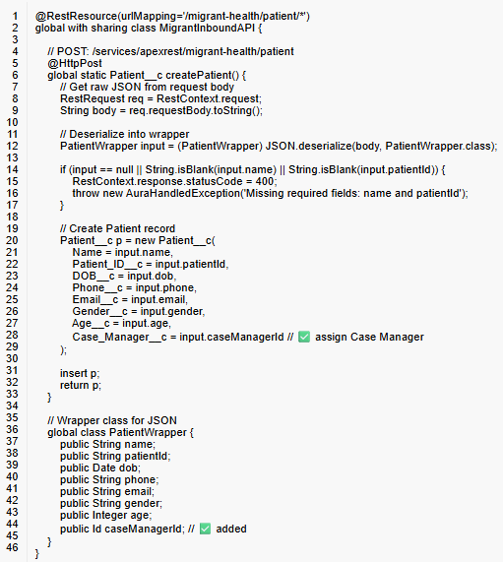

### Step 2 – Prepare JSON for API

Example JSON to send via Workbench:

{  
 "name": "Integration Test Patient",  
 "patientId": "P-777",  
 "dob": "1990-05-05",  
 "phone": "9998887777",  
 "email": "testpatient@demo.com",  
 "gender": "Female",  
 "age": 34,  
 "caseManagerId": "005gK000005eLdx"  
}

### Step 3 – Execute POST request

1. Method: POST
2. URI: /services/apexrest/migrant-health/patient
3. Paste JSON body (from Step 2)
4. Click **Execute**

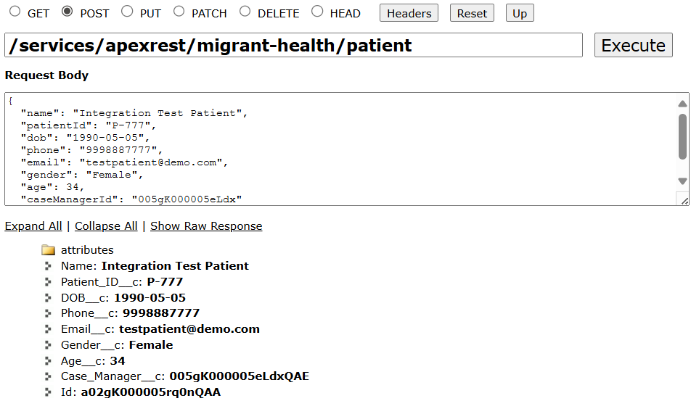

### Step 4 – Verify Response

* Check response JSON to confirm patient record created
* Go to **Patients tab** → confirm new patient exists

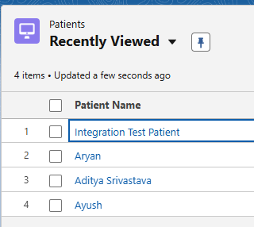

## Part B – Outbound API Testing (Salesforce sends data)

### Step 1 – Prepare Named Credential

* Setup → Named Credentials → New
* Label: Migrant External API
* URL: https://httpbin.org
* Identity Type: Anonymous
* External Credential: No Authentication

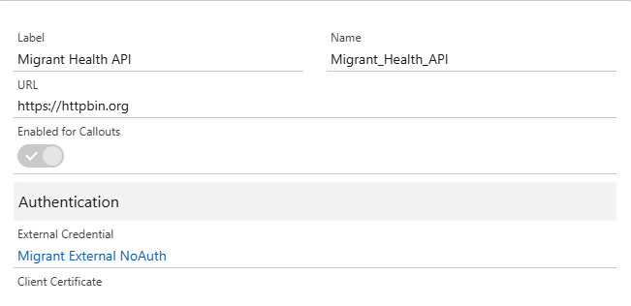

### Step 2 – Apex Outbound Class

* Class: MigrantOutboundService
* Uses @future(callout=true)
* Sends JSON payload to external system

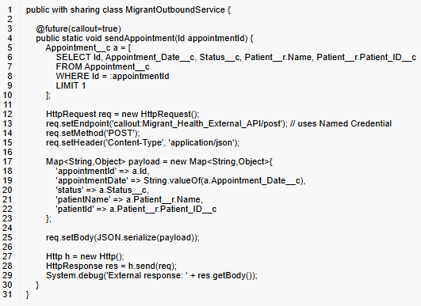

### Step 3 – Trigger

* Trigger: AppointmentTrigger (after insert)
* Calls MigrantOutboundService.sendAppointment(a.Id)

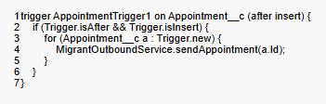

### 

### Step 4 – Create Test Appointment

* Go to **Appointments tab → New**
* Fill Patient, Appointment Date, Status
* Save

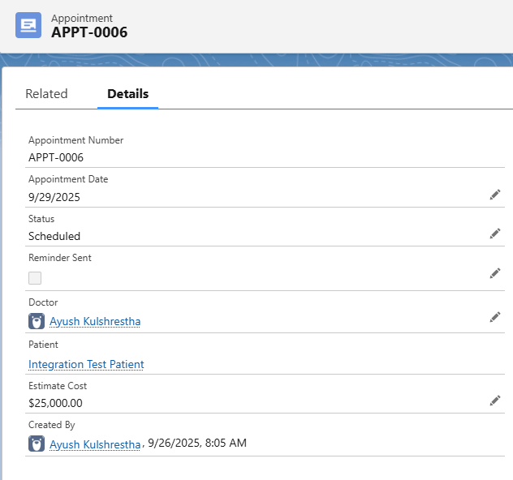

### Step 5 – Debug Logs

1. Setup → Debug Logs → Add monitored user
2. Create Appointment → Flow triggers outbound call
3. Check Debug Logs → search USER_DEBUG | External response:
4. Confirm JSON payload sent

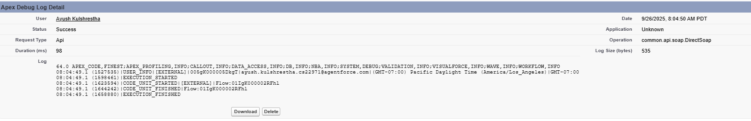

Example JSON sent:

{  
 "appointmentId": "a0BXXXXXXXXXXXX",  
 "appointmentDate": "2025-09-26",  
 "status": "Scheduled",  
 "patientName": "Integration Test Patient",  
 "patientId": "P-777"  
}